Teachers’ Notes for Let’s Go Shopping, Grandma!
Let’s Go Shopping, Grandma! is a funny role-reversal tale of a stubborn grandma on her shopping trip with her ever-so-patient and independent young granddaughter. Besides the pure entertainment factor, this book by Sharon Giltrow and Dhwani Gosalia also creates a wonderful array of learning opportunities and play experiences that will help children in many developmental and interpersonal areas of growth. Further, it’s a great chance to celebrate both World Teachers’ Day and National Grandparents Day with some fun activities! Enjoy! 🙂
Discussion
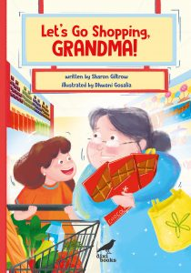
Do you have a favourite activity or memory about spending time with a grandparent?
What things are you better at doing than your grandparent?
Do you like to visit the shops with your grown-up? Why or why not?
What is your favourite treat? What is your grown-up’s favourite treat?
Look at the cover of ‘Let’s Go Shopping, Grandma!’ What do you notice? How do you think the characters are feeling? How does it make YOU feel? What might happen in this story?
What was your favourite part of the story? Why?
Activities
For ages 4 to 8.
Images courtesy of Dhwani Gosalia, from Sharon Giltrow’s website.
English (Foundation to Year 2)
Use the image below to:
- Write adjectives (describing words) about the characters. AC9E1LA07, AC9E2LA07
- Create a character profile, describing the behaviours, appearance, likes, dislikes, etc of a character. AC9EFLA08, AC9E1LE01, AC9E2LE01, AC9EFLE02, AC9E2LE02, AC9EFLE03, AC9E1LE03, AC9E2LE03
- Innovate and complete the sentence, “When it’s time to go to the shops…” AC9EFLE05, AC9E1LE05, AC9E2LE05
- Write a role-reversal narrative about a young child being in charge of a grown-up. AC9EFLE05, AC9E1LE05, AC9E2LE05, AC9EFLY06, AC9E1LY06, AC9E2LY06
- Write ‘an essential guide’ (or procedural text) on ‘How to…’ (for example, take a grown-up shopping, get them ready for work, bed, etc). AC9EFLY06, AC9E1LY06, AC9E2LY06
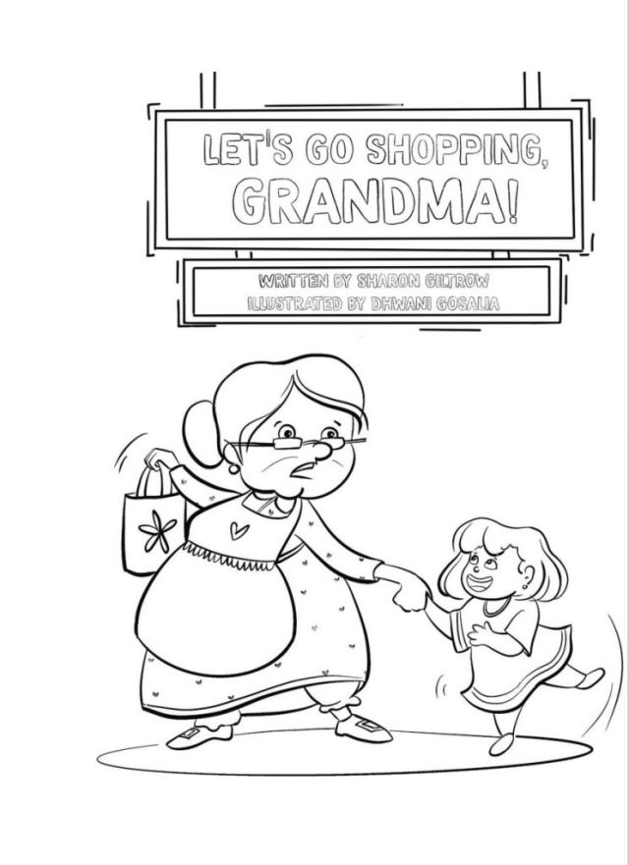
Mathematics (Foundation to Year 2)
AC9MFN05, AC9MFN06, AC9M1N04, AC9M1N05, AC9M1N06, AC9M2N04, AC9M2N05, AC9M2N06
Use the images below to:
- Create a shopping list using a supermarket catalogue (or your own catalogue) or real/toy items with prices.
- Draw, cut out or choose the items you will buy, and add them to your shopping trolley/cart/basket.
- Add up the total cost of all the items.
- Count the money you need to pay for the items. Will you need change? Calculate the change as necessary.
- Create mathematical problems, such as limiting the spend to $10/$20/$100, etc, or limiting the number items to a maximum of 5, or maybe Grandma added a chocolate bar and now you need to subtract the cost, etc.
- Note: students can role play different scenarios with a partner. You might like to include other props like a cash register, scanner, etc.
- 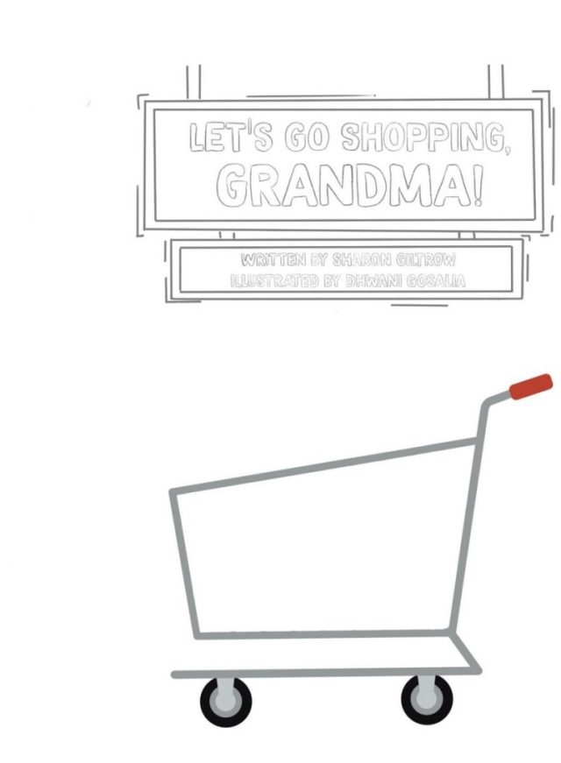
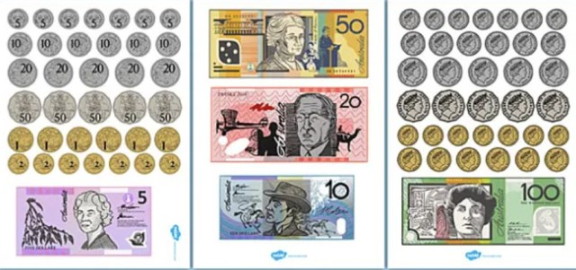
Health and Physical Education (Foundation to Year 2)
AC9HPFP03, AC9HP2P03, AC9HPFM01, AC9HP2M01, AC9HPFM03, AC9HP2M03, AC9HPFM04, AC9HP2M05
Visual Arts (Foundation to Year 2)
AC9AVAFC01, AC9AVA2C01, AC9AVAFP01, AC9AVA2P01
Use the image below as inspiration to:
- Make a card with a special (or funny) message for a grandparent.
- Take a fun photo (or draw a picture) with a grandparent and create a nice frame to put it in.
- Take your grandparent out on a special adventure!
- Try and do something active with a grandparent (for example, a bush walk, a bike ride, etc).
- Colour in the activity sheets and make a book for your grown-up.
- Read your favourite books together!
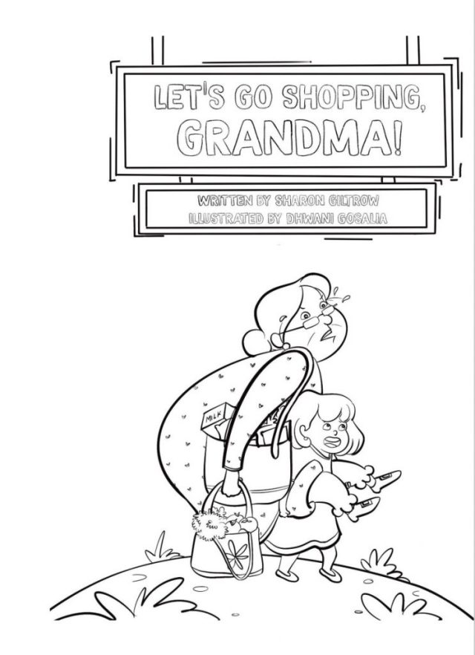
More colouring in sheets can be found at Sharon Giltrow’s website.
National Grandparents Day is on Sunday October 29!
Let’s Go Shopping, Grandma! is written by Sharon Giltrow, illustrated by Dhwani Gosalia, and published by Dixi Books. Notes prepared by Romi Sharp.

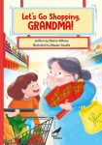
Please find Sharon Giltrow at her website: Author | Sharon Giltrow (sharongiltrowauthor.com)
Facebook | Instagram | Twitter | Pinterest
Let’s Go Shopping, Grandma! is available for purchase through Dixi Books | Amazon | Dymocks | Paper Bird Children’s Books.

